Dvs Technologies Aws Terraform

Compiled and Scrutinized by
Mr. Shaan Shaik
(Senior DevOps Lead)

Words To The Students

Though we have taken utmost efforts to present you this book error free, but still it may contain some errors or mistakes. Students are encouraged to bring, if there are any mistakes or errors in this document to our notice. So that it may be rectified in the next edition of this document.

“Suppressing your doubts is Hindering your growth”.

We urge you to work hard and make use of the facilities we are providing to you, because there is no substitute for hard work. We wish you all the best for your future.

“The grass isn’t greener on the other side; the grass is greener where you water it.”

You and your suggestions are valuable to us; Help us to serve you better. In case of any suggestions, grievance, or complaints, please feel free to write us your suggestions, grievance and feedback on the following
Dvs.training@gmail.com

Jenkins Email notification configuration

Install the required plugins in the jenkins, please follow the below.

Email Extension Plugin
Email Extension Template Plugin
Mailer Plugin

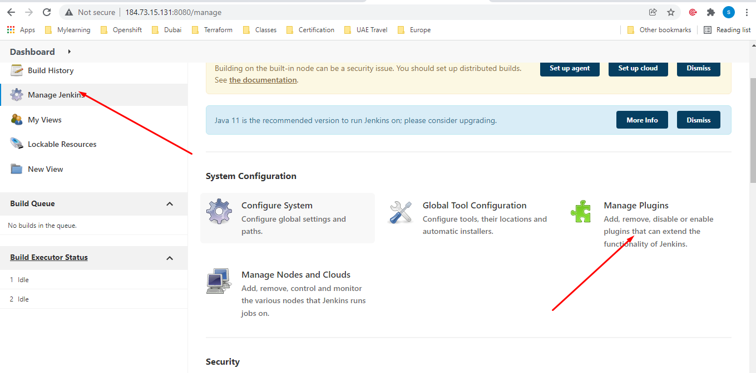

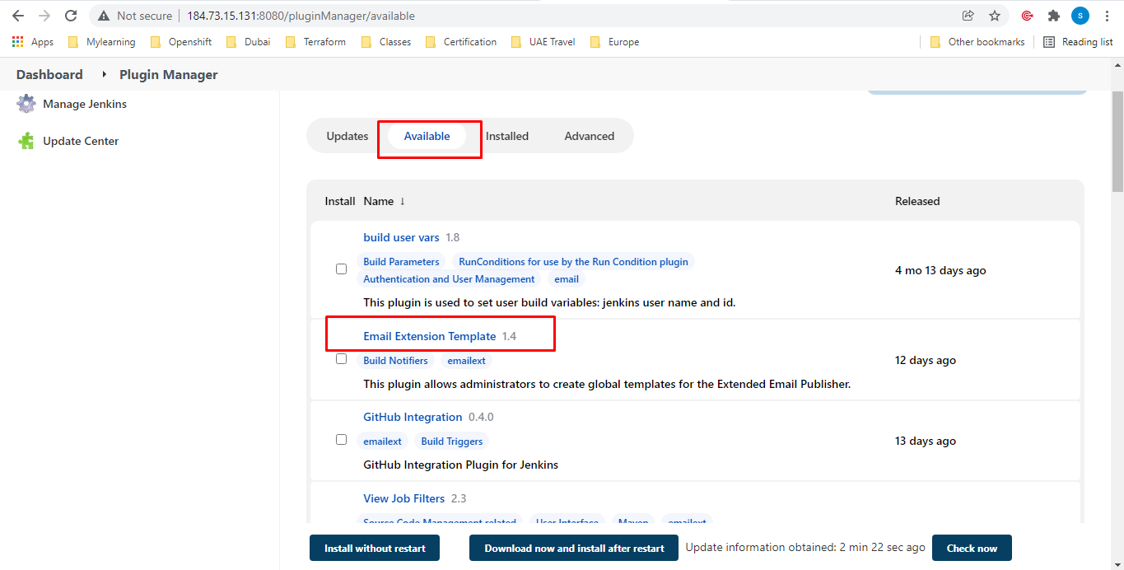

Click on install & restart jenkins

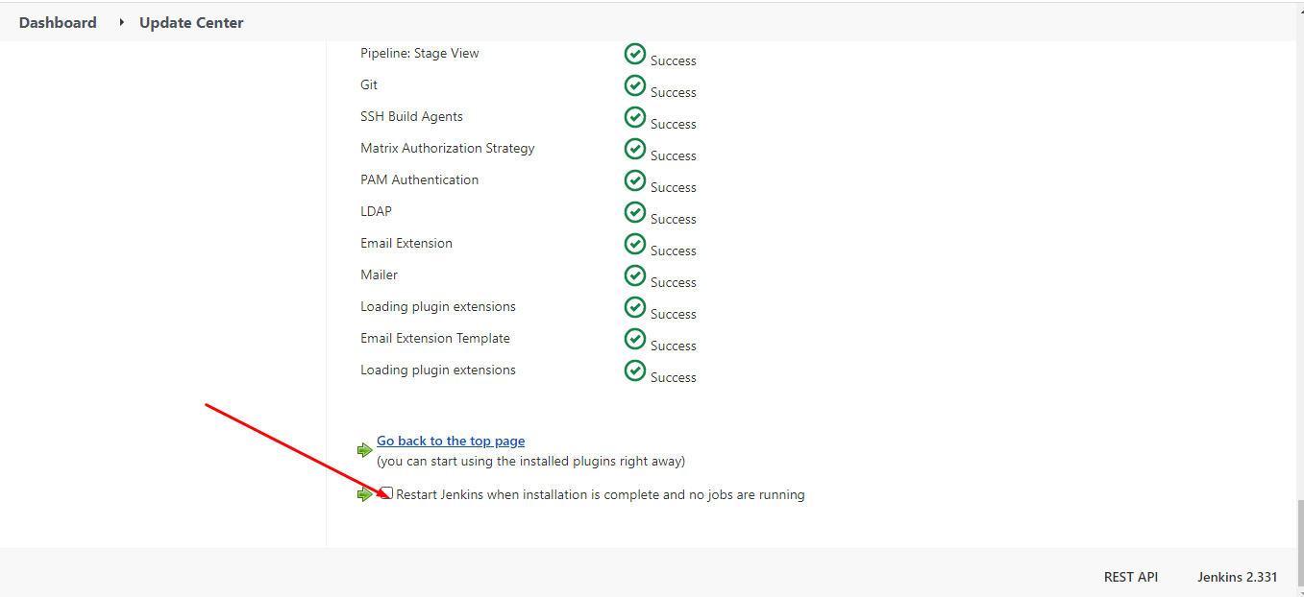
Note: Make sure that you have below plugins installed in the jenkins

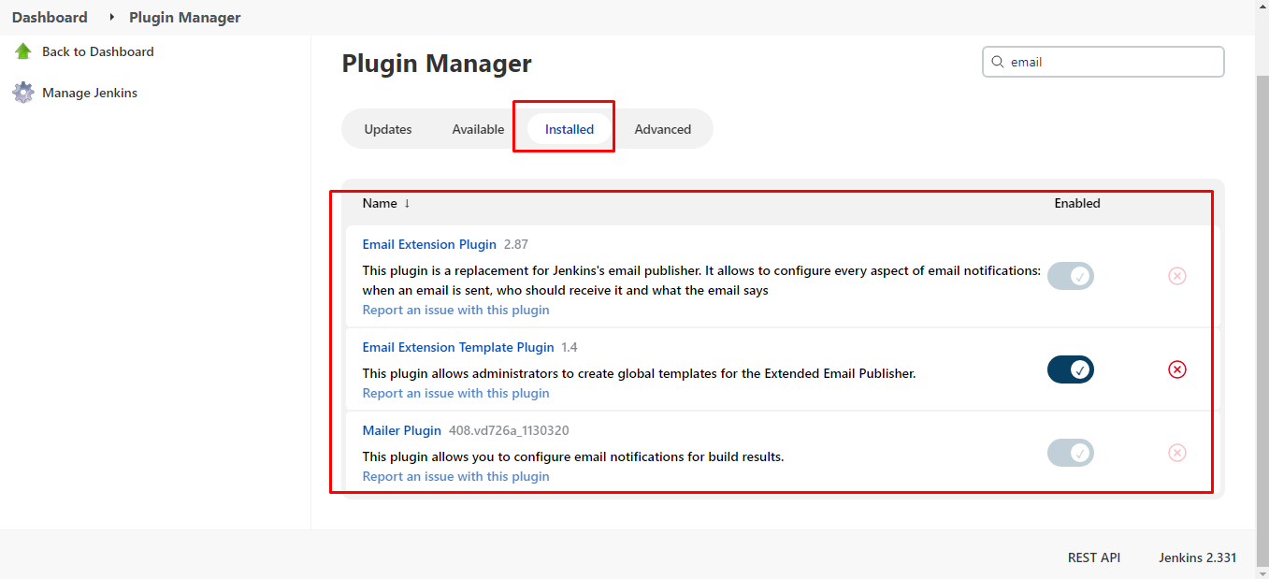

Make sure that you are following below for allowing gmail access:

https://myaccount.google.com/lesssecureapps

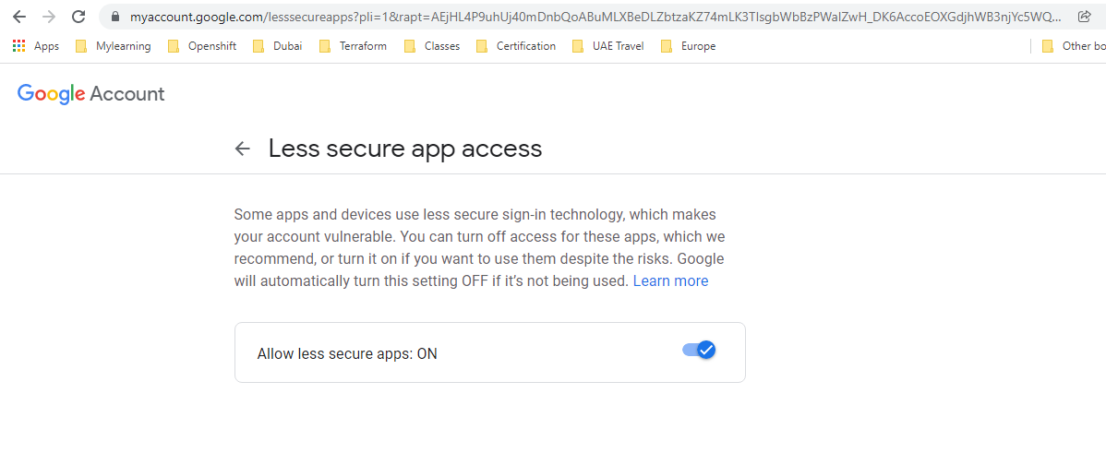

https://accounts.google.com/DisplayUnlockCaptcha

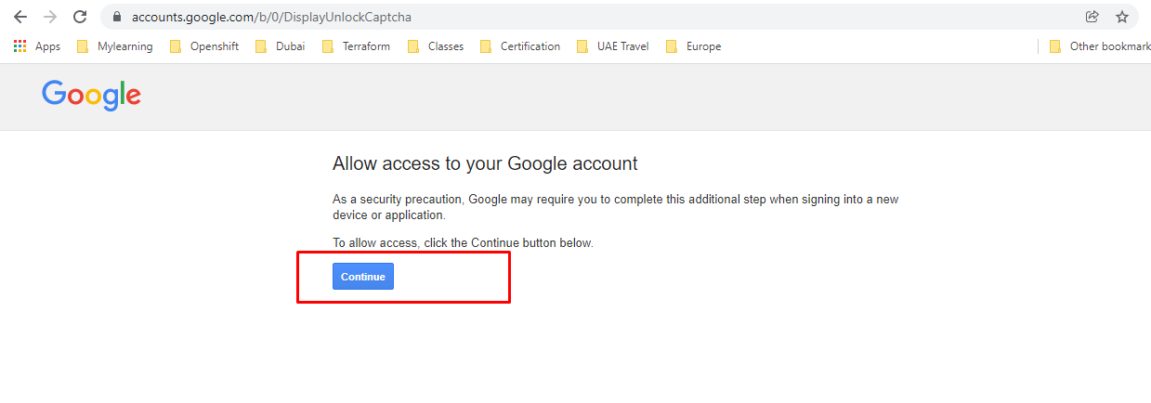

Click on continue

Configure the jenkins email plugin:

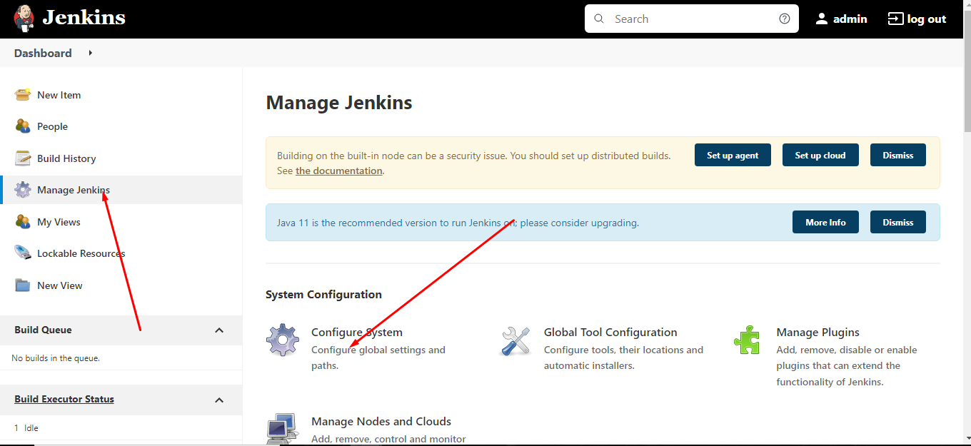

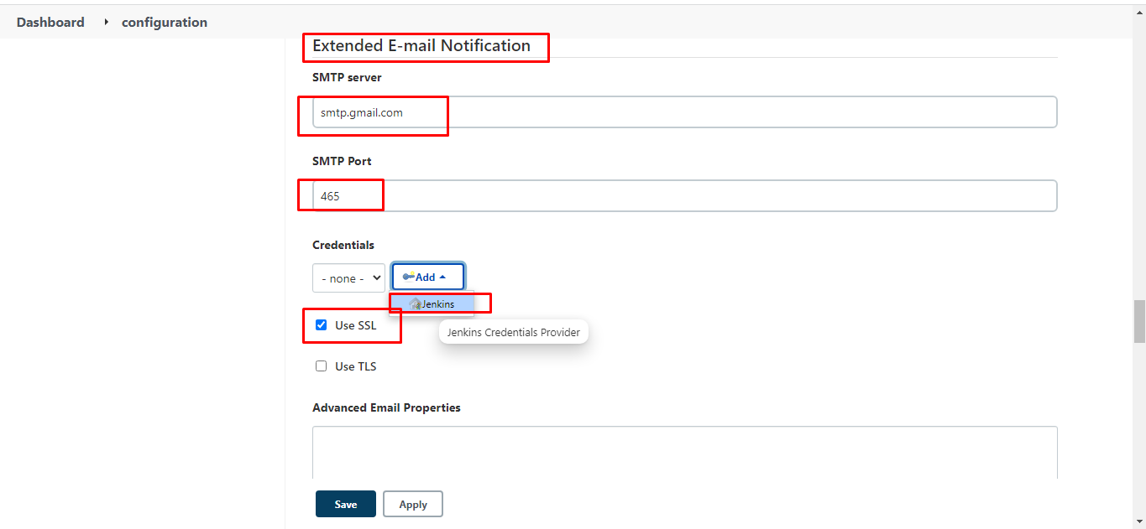

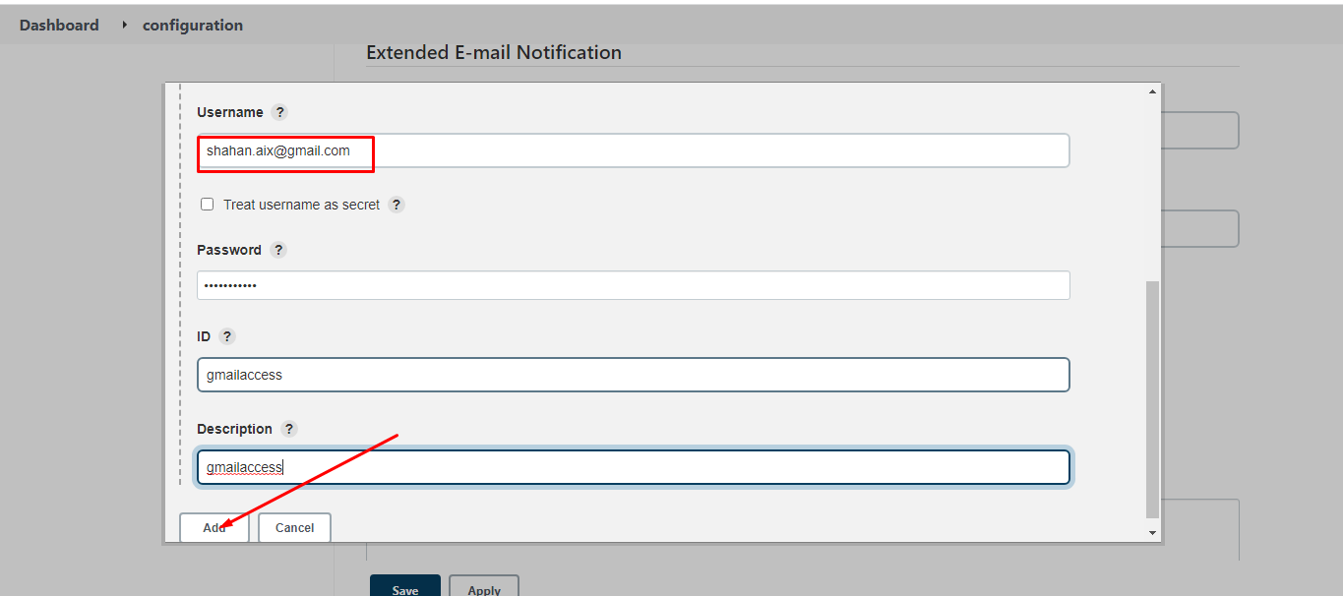

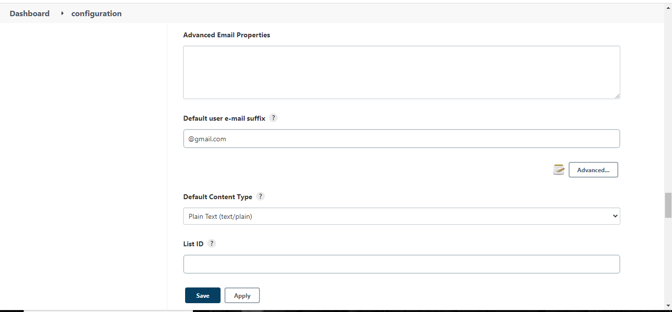

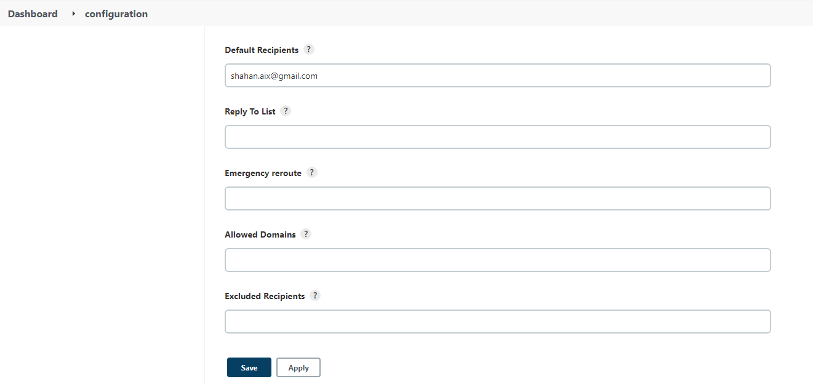

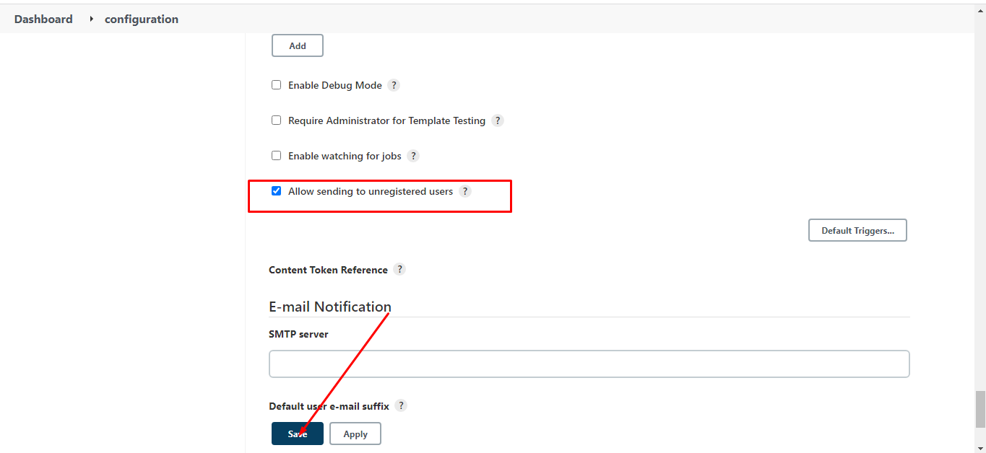

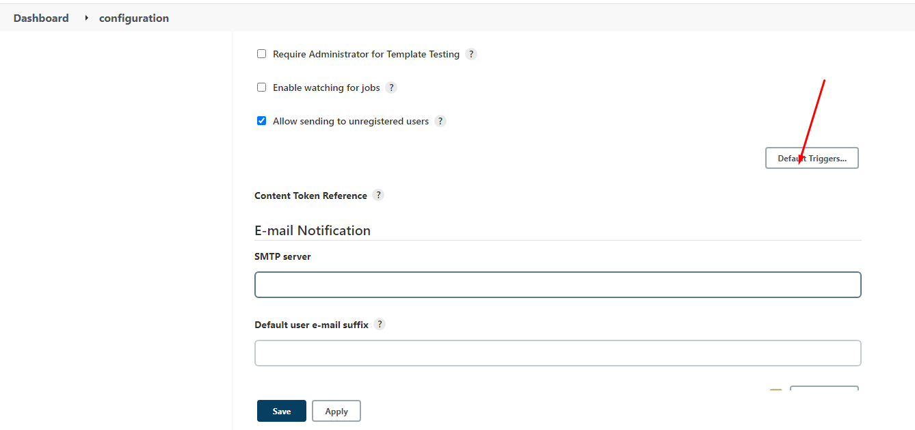

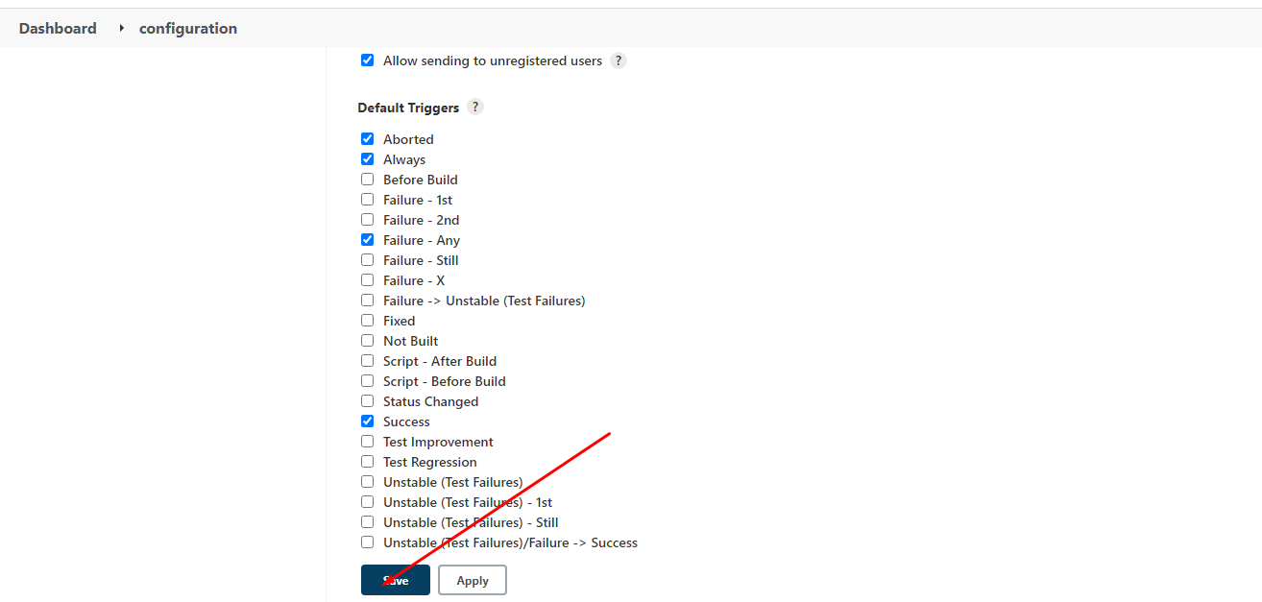

Configuring build job:

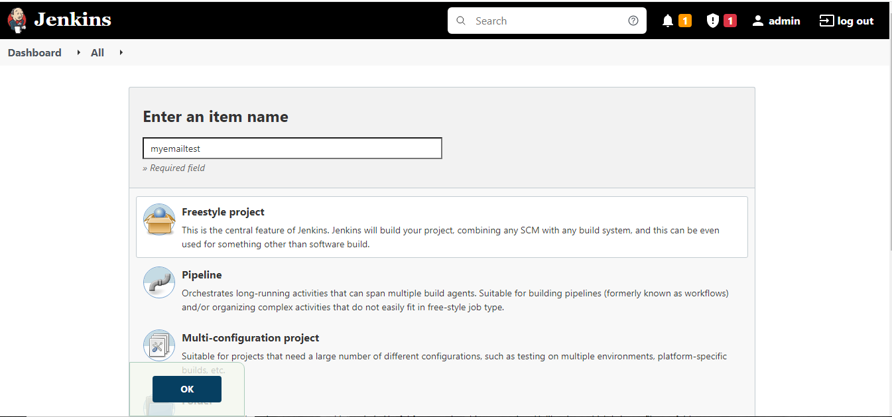

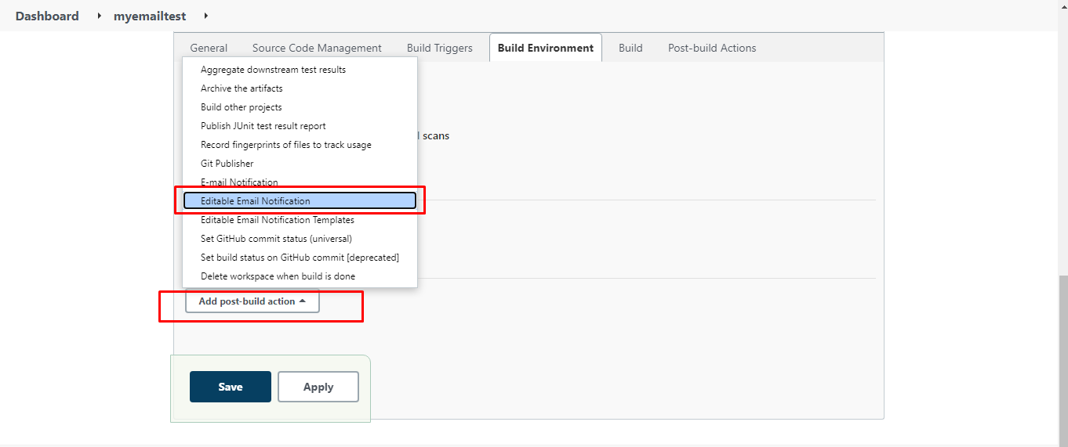

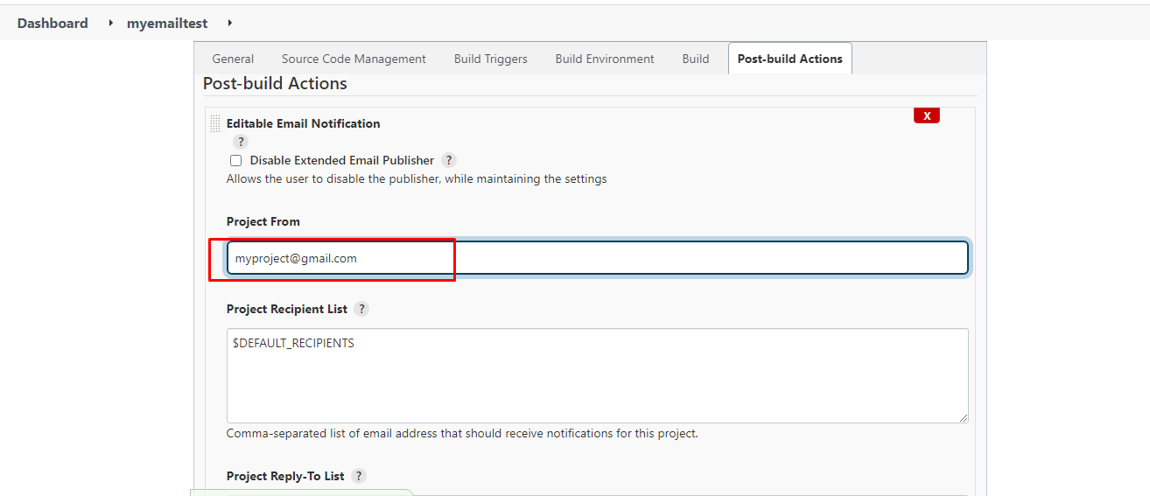

Leave everything as it is. Click on save.

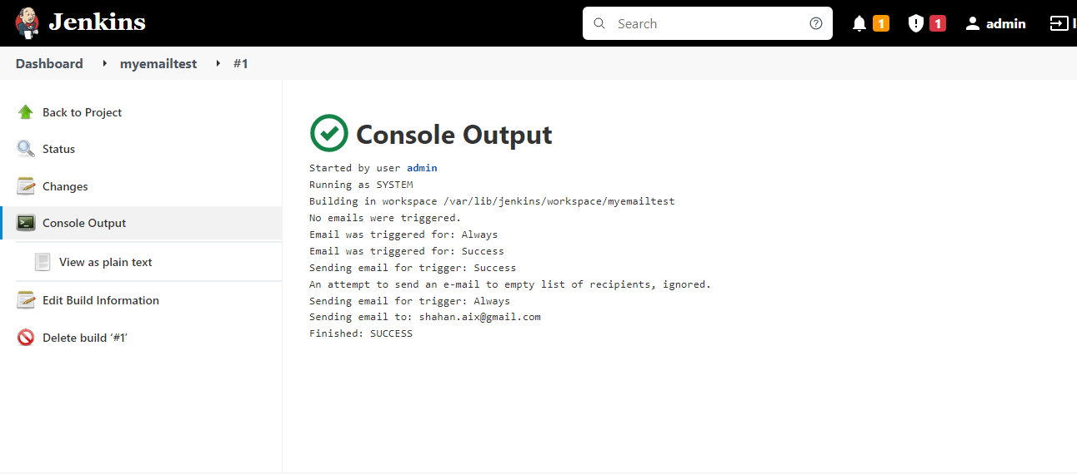

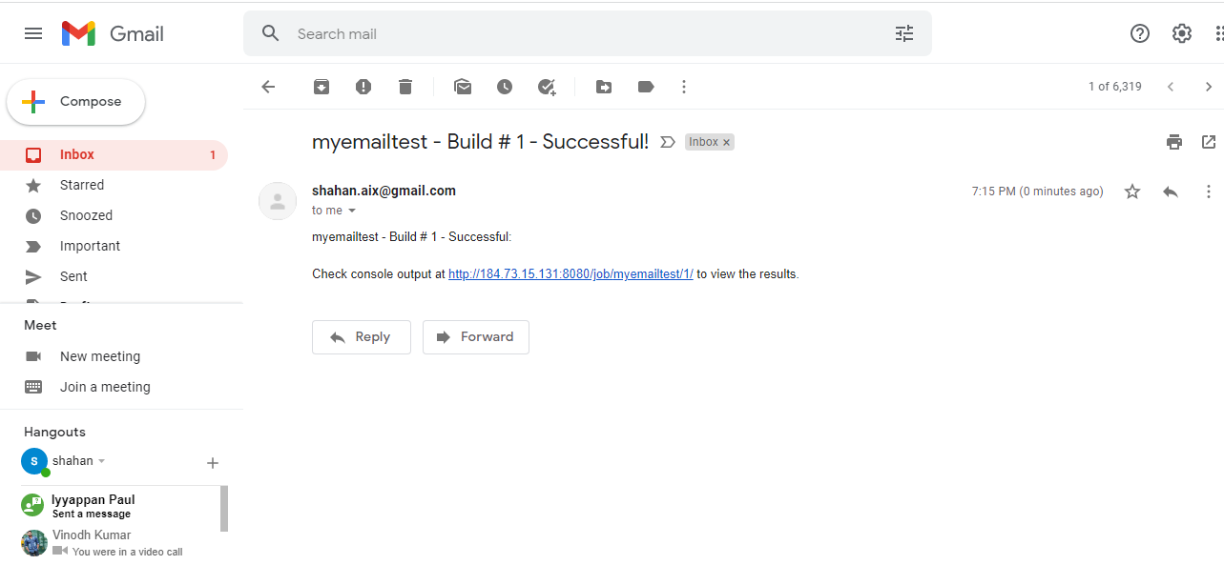

If you want to have Jenkins pipeline then you can use the below.

pipeline {
agent any
stages {
stage('Gmail')
{
steps
{
emailext body: """*${currentBuild.currentResult}:* Job Name:
${env.JOB_NAME} || Build Number: ${env.BUILD_NUMBER}\n More
information at: ${env.BUILD_URL}""",
subject: 'Declarative Pipeline Build Status',
to: 'shahan.aix@gmail.com'
}
}

}
}

